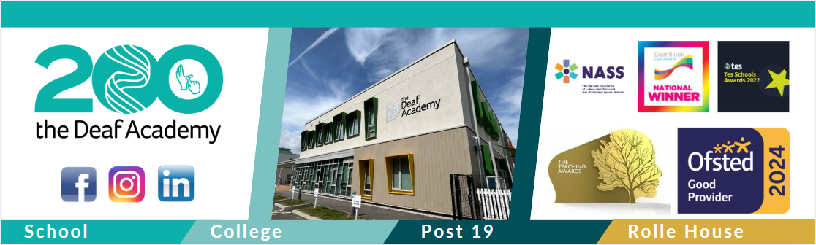

Vocational Profile

Name…………………………………………………………
Date profile started ___/___/___
My Personal Details

Name ____________________________________________________________________
DOB ___/___/___ NI no. ___ ___ ___ ___ ___ ___ ___ ___ ___
Email __________________________@_________________________________________
Address __________________________________________________________________
___________________________________________________________________________
___________________________________________________________________________
Phone Number/s __________________________________________________________
The best way to contact me…
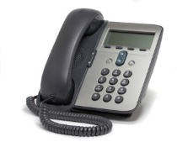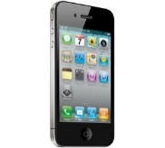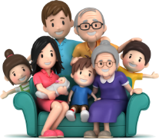
Telephone Mobile Email keyworker Family/Carers

Other…

My Aspirations
After college I would like to…
Work (get paid) Volunteer (unpaid) Part-time Full-time
I am interested in…
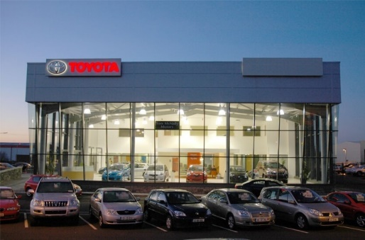
Working in an office Working with cars

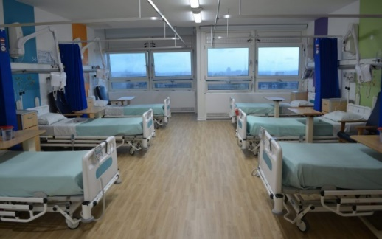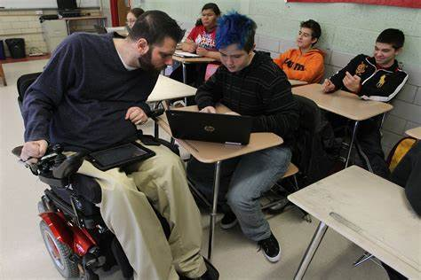
Working in a hospital Working with children/young people

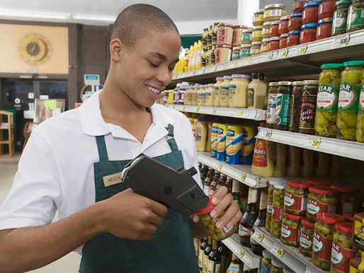
Working in a shop Working in a warehouse

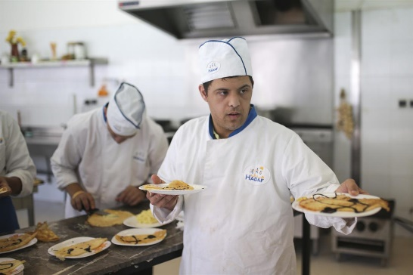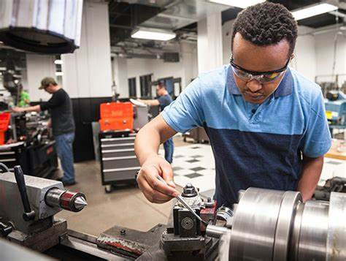
Working in a kitchen Working with machines
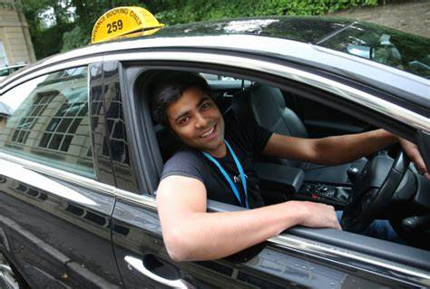
Working in hair and beauty Driving as a job

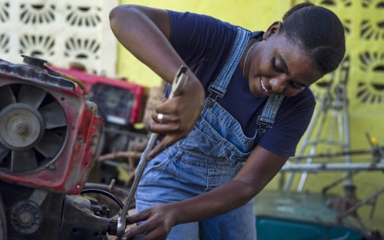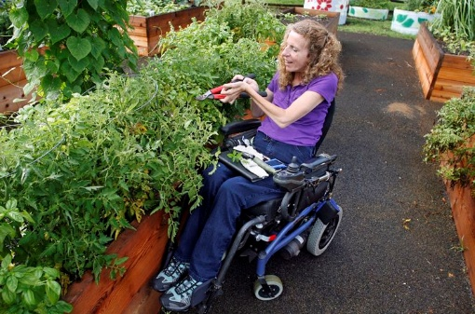
Working with tools Work in gardening

Other...

My Personality


Anxious Creative Brave


Calm Confident Friendly Happy
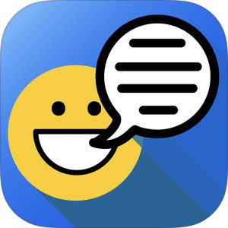
Helpful Shy Chatty

Other…

My Hobbies
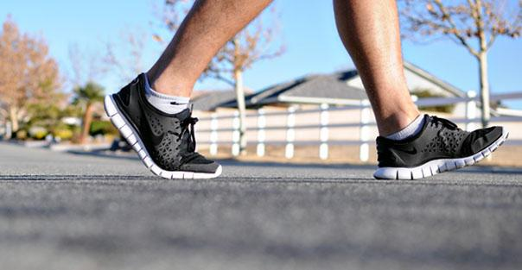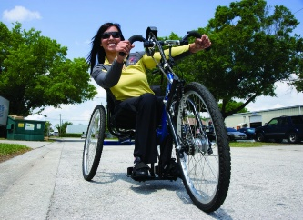
Walking Running Cycling
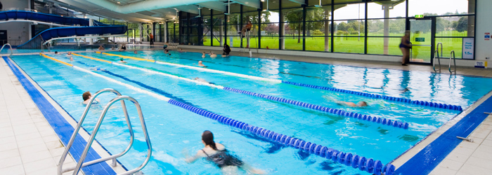
Swimming Ice skating Listening to music

Using a computer Social media You Tube
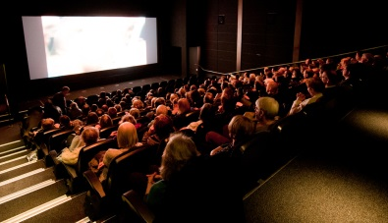

Watching movies Arts and crafts Going shopping
Other…

My Health Information
I have a diagnosis of…
Autism ADHD Learning difficulties Dyslexia
Cerebral Palsy Epilepsy Asthma Hearing Impairment
Allergies Diabetes Visual Impairment Speech difficulties
Other…

That means I find the following things difficult…
Telling the time  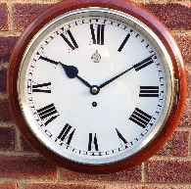 | Speaking to people I don’t know 
Understanding written information  | Following instructions  
Dealing with stress/anxiety 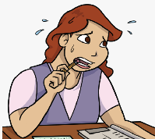 | Being in busy places  
Staying concentrated | Dealing with last minute changes to routine  
Remembering multiple instructions  | Making decisions  
Speaking up in front of a group  | Remaining positive  
Other …


Do you take medication? Yes No
If yes, do you need help to take your medication? Yes No

Physical Skills
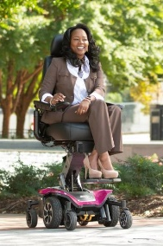
Do you use a wheelchair?
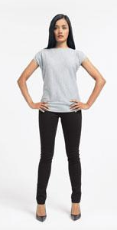
Can you stand for 2 hours or more without difficulty?
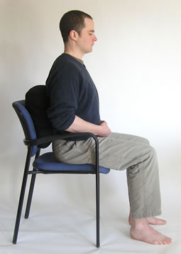
Can you sit down for 2 hours or more without difficulty?

Can you walk without assistance/difficulty?
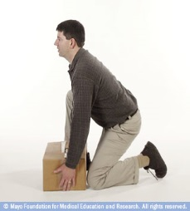
Can you kneel down easily?
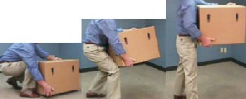
Can you lift and carry things?

Are you ok at using your hands?
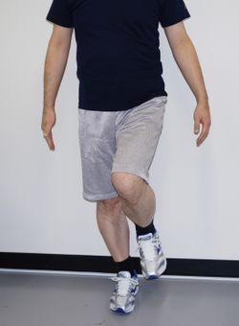
Can you balance without assistance?
Other…

Travel Skills
What types of transport can you use?
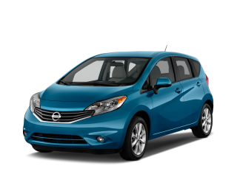  Car | 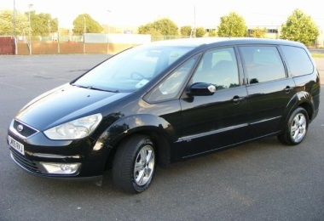  Taxi | 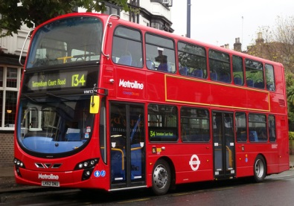  Bus
Independently | Independently | Independently
With Support | With Support | With Support
  Walking | 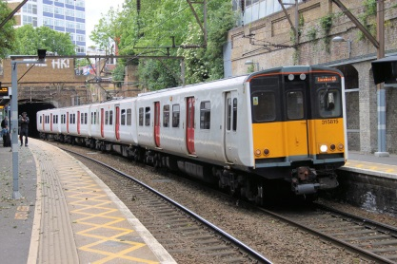  Train | 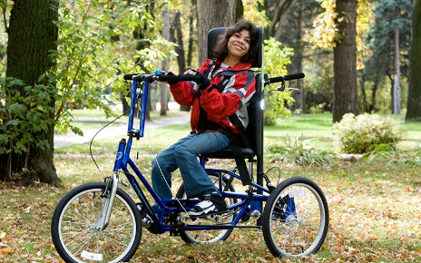Cycling
Independently | Independently | Independently
With Support | With Support | With Support
Other…

Independently
With Support

Do you have a travel pass? Yes No

Communication Skills

Please circle your main method to communicate with others;
British Sign Language (BSL)  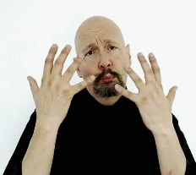 | Written information  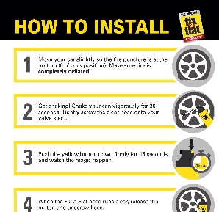 | Makaton  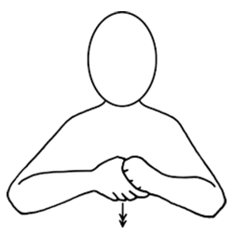 | Communication Device  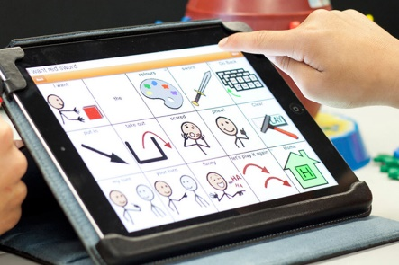
PECs  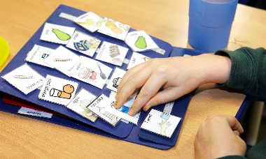 | Speaking 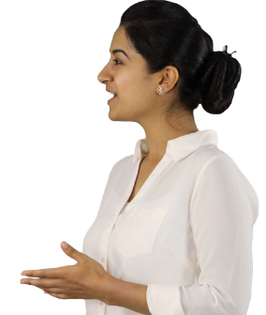 | Other…

Money Skills

Do you have a bank account? Yes No
Do you use cash? Yes No
Do you use a card? Yes No
Do you use a cashpoint? Yes No
Do you use online/telephone banking? Yes No

Organisational Skills
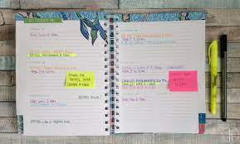
How do you organise yourself?
Do you need support from other people to make sure you know the time and where you need to be? Yes No
Do you use a phone to tell the time and set reminders? Yes No
Do you use a watch to tell the time? Yes No
Do you understand the 24 hour clock? Yes No
Do you understand the 12 hour clock? Yes No
Do you use a diary to keep track of your appointments? Yes No
Do you wake yourself up in the morning? Yes No
Support I need at work…
Health

Telling the time

Speaking to people I don’t know

Understanding written information
Following instructions

Dealing with stress/anxiety

Being in busy places

Staying concentrated

Dealing with last minute changes to routine

Remembering multiple instructions

Making decisions

Speaking up in front of a group

Remaining positive

Medication
Physical
Travel
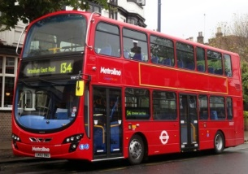
Communication

Money

Organisation
Other
All personal data shall be processed in accordance with Data Protection Legislation (GDPR and the Data Protection Act 2018). For the purposes of the Data Protection Legislation, The Deaf Academy is the data controller and the Company is the data processor (where Data Controller and Data Processor have the meanings as defined in the Data Protection Legislation). The data processor will ensure it has in place appropriate technical and organisational measures, to protect against unauthorised or unlawful processing of data and against accidental loss, destruction of, or damage to, the data. The data processor will ensure that all personnel who have access to and/or process the data are obliged to keep the data confidential and will only retain the data for as long as necessary and when it is no longer needed it will be securely deleted, except where such retention is necessary for compliance with a legal obligation.

